|  |  |
| --- | --- |
|  | Actors and Goals |
|  |  |
| Generated 3/15/2015 | 350project |
|  |  |

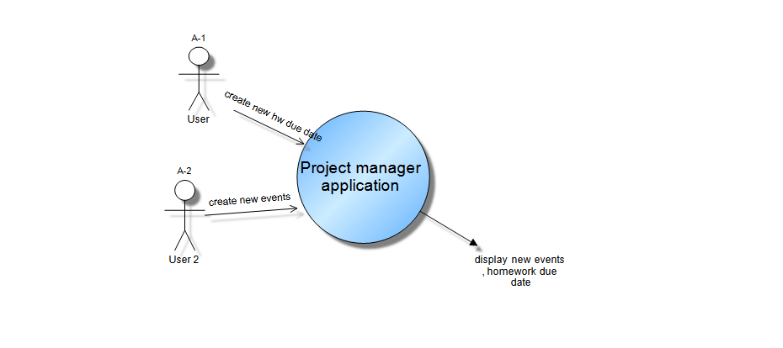

| Actor | Description | Goals |
| --- | --- | --- |
| A-1 | User  A person who wants to create a new project or new home work assignment | * Keep track of assignment due date * Keep track of time for assignment |
| A-2 | User 2  A person wants to create an event. | * Remind time , location ........... |